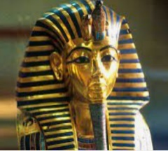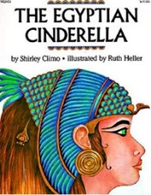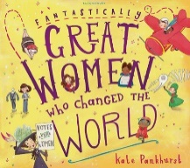****

**Design and Technology**

During our ‘digital world’ unit, children will design, develop a program, house and promote a Micro: bit electronic charm.

**History**

This term, children will focus on Ancient Egypt, they will date and sequence historical events, note connections and explain the difference between primary and secondary sources. Also, they will use a range of sources to answer historical enquiries and understand how the past is constructed.

**Science**

During our ‘animals including humans’ unit children will learn how to identify that animals, including humans, need the right types and amount of nutrition, and that they cannot make their own food, they get nutrition from what they eat. In our ‘plants’ unit, children will learn how to identify and describe the functions of different parts of flowering plants and they will explore the requirements of plants for life and growth and that they vary from plant to plant.

**P.E.**

During our multi-skills unit, children will demonstrate a range of skills such as developing co-ordination, balance and control. During our brilliant ball skills unit, children will learn how to dribble a ball with control, develop throwing techniques and catch with increasing control and accuracy.

**French**

Children will focus on language relating to fruits and musical instruments.

**Talks/Workshops**

**Reading and Maths workshops**

**Egyptian Workshop**

**Spring Term Year 3**

**Visits**

**Library**

**Geography**

Children will be exploring North America. They will locate North America and some of its key features on a world map. They will use world maps to investigate lines of longitude and latitude. Also, they will use map references to locate specific places within the continent.

**English**

Our first focus text will be ‘Great Women that changed the World.’ Children will be exploring a range of writing outcomes and will focus on writing a letter, newspaper and biography. We will then focus onto the text ‘Egyptian Cinderella’ where the children will be focusing on writing a diary, setting description about Egypt and create an invitation to a ball. In reading, children will explore the meanings of words in context, read a range of texts and practise comprehension style questions which focus on vocabulary, retrieval and inference skills.

**Computing**

Children will be focusing on digital literacy through exploring stop frame animation and then move onto computer science and coding and will learn all about internet safety.

**Art**

Throughout our ‘Prehistoric Art’ unit of work, children will be learning about how and why Art was created thousands of years ago.

**Maths**

During this term, children will continue to work on recalling and using multiplication and division facts for the 3, 4 and 8 times tables. We will move onto money where children will learn how to convert between pounds and pence. In our statistics unit, children will interpret and present data using bar charts, pictograms and tables. In our length unit, children will convert between single and mixed units and compare, order, add and subtract measurements of length. In our fraction’s unit, children will count up and down in tenths, recognise and show, using diagrams, equivalent fractions with small denominators and add and subtract fractions.

**Music**

Music sessions will focus on whole class keyboards. Children will focus on pitch, tempo and dynamics. They will play in an ensemble and solo context and further develop skills in control and accuracy.

**R.E.**

Children will focus on exploring what kind of world did Jesus want and why do Christians call the day Jesus died ‘Good Friday?’

**PSHE**

This term, we will cover our ‘dreams and goals’ and our ‘healthy me’ units. Please see our school website for more information.